Creating a House Number

This lesson focuses on forming 3-digit house numbers to meet specific requirements. Careful reading of information and understanding of mathematical language are important to finding appropriate solutions. Using the problem-solving strategies of looking for patterns and establishing an organized list will aid students in finding all the possible solution sets.

Learning Objectives
Students will:
- experiment with numbers to find all possible ways to add three different digits to obtain a given sum (6)
- explore the ways three digits can be placed together to form different three-digit numbers
Materials
Create a House Number Activity Sheet
Numeral Cards
Scissors

Instructional Plan
In this lesson, students will attempt to find a three-digit house number that meets certain criteria. Review some examples of three-digit numbers that would be familiar to students.
You may wish to draw a house, similar to the one shown below, on the board or overhead projector. Be sure that the house has three slots where the digits of the house number could be placed.

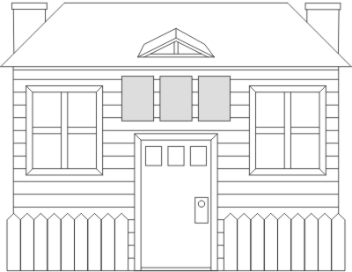
Hold up the Numeral Cards for 3, 0, and 1.
Ask students what they notice about the three-digit number formed by those digits. They may notice that:
- the digits are different
- the sum of the digits is 4.

Ask students if there is another way to get a sum of 4 using any of the numeral cards. Students may suggest the following:
103
130
112
121
211
013
031
022

Ask students how they know when they've listed all of the possible number combinations. Be sure to point out the combinations where the digits are all different.
Present the following problem to students:
- The house number has three different digits.
- The sum of the three digits is 6.
- The number does not begin with 0.
- What could the house number be? List all possible numbers.

Distribute the Create a House Number activity sheet.

Have students cut the digits from the bottom of the activity sheet. They will use these tiles to physically generate the three-digit number combinations.
Allow students some time to work on the problem individually. Then, allow students to work with a partner to discuss their answers. In particular, they should attempt to create a complete list, which may be accomplished by combining the answers they attained individually. Students should compare their lists, noting any "repeats" or missing number combinations.

Lead a discussion to arrive at a conclusion. The discussion should include the need for keeping an organized list, so that students can be sure when they have found all possibilities. Students should also discuss how house numbers were found. For example, they might mention that they tried to find a set of three numbers that met one criteria (for instance, the set had a sum of six) but then removed those sets that did not meet the other criteria (for example, remove sets with digits repeated). Continue the discussion until students are convinced that they have found all possible house numbers.

Solutions to the Create a House Number activity sheet are as follows.
There are 14 house numbers that meet the given criteria:
123
132
213
231
312
321
105
150
501
510
204
240
402

